**Name: Ashish Mukherjee**

**Class: LY CSE NS –‘A’**

**Roll No: 2193060**

**Subject: NML**

**Assignment 13**

**Objective**: Use netbalancer tool to control your traffic with priorities and rules.

# Theory:

NetBalancer is an internet traffic control and monitoring tool designed for Win7/8/10.

You can use NetBalancer to set download/upload transfer rate priority for any applications and monitor their internet traffic.

Applications with a higher network priority will gain more traffic bandwidth than those with a lower one.

Features of netbalancer:

* NetBalancer is a Windows application for local network traffic control and monitoring
  + Browse and do any internet activity comfortably on your PC even when your download manager or torrent client downloads huge files from the internet - just lower their network priority with NetBalancer.
* Manage your PC network traffic with rules
  + With traffic rules you can set priorities, limit or block your metered network traffic based on various settings like time of day, network protocol or application type.
* Monitor and limit unwanted traffic with DPI (Deep Packet Inspection)
  + With deep packet inspection you can block BitTorrent traffic, limit the Steam application and set a high network priority for your browser or games.

# Procedure:

After installing the netbalancer application, the interface shows all the running apps and info regarding them.

The info contains the priority, download-upload speed, no. of connections, path Etc.

Using the priorities we can set which applications to prioritize the bandwidth. Processes with a High priority will get more bandwidth than those with Normal or Low.

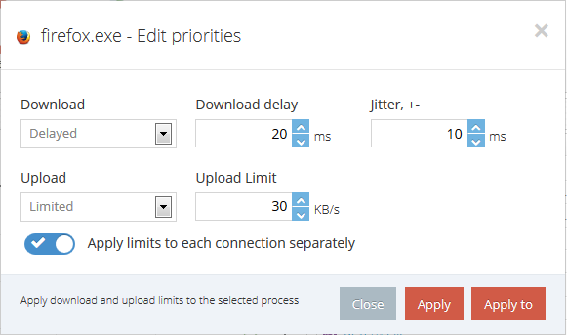

The Rules are a more advanced method of setting priorities and limits for your traffic. While the basic functionality permits you to set priorities and limits on a per process basis, Rules can be set specifying the network adapter, remote or local IP and Port, network protocol, time and more.

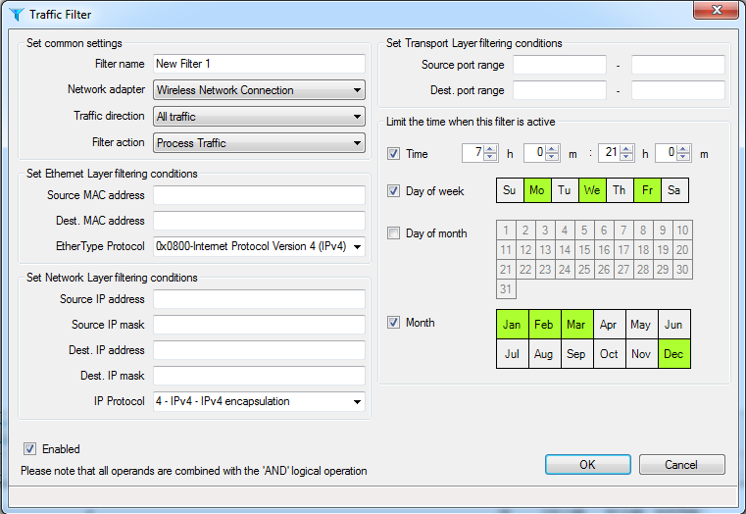

**Conclusion:** Netbalancer was successfully used to control the traffic using priorities and rules.